**Name: Sreelekshmi Anilkumar**

**Roll No:42**

**Batch: Mca B**

**Date:30-3-2022**

**NETWORKING & SYSTEM ADMINISTRATION LAB**

**Experiment No.: 4**

**Aim**

Familirization of Linux Commands.

**Procedure**

1. Cat > filename :- Create a new file and add content to that file.

$cat > b1.txt

**Output Screenshot**

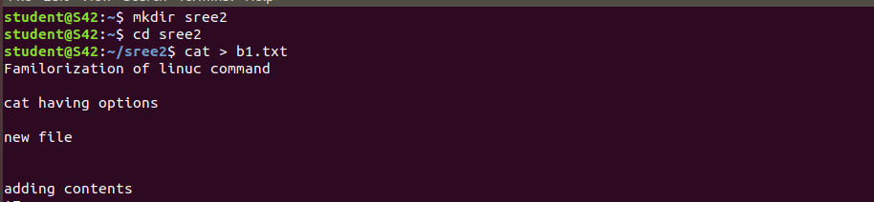

1. Cat >> filename :- For additional information to that file.

$cat >> b1.txt

**Output Screenshot**



1. Cat filename:- To put the line numbers.

$cat b1.txt

**Output Screenshot**



1. Cat file1 > file2 :- To copy file content of one file to another file.

$cat b1.txt > b2.txt

$cat b2.txt

**Output Screenshot**



1. Cat –n filename :- Content with line number.

$cat –n b1.txt

**Output Screenshot**



1. Cat –b filename :- Removing empty file and reordering the line number.

$cat –b b1.txt

**Output Screenshot**



1. Touch :- Is used create an empty file.

$touch b3.txt

**Output Screenshot**



1. Cat >> filename :- For additional information to that file

$cat >> b1.txt

**Output Screenshot**



1. head filename :-Display firs 10 commands on the file.

$head b1.txt

**Output Screenshot**



1. head -4 filename :- Display first 4 commands on the file.

$head -4 b1.txt

**Output Screenshot**



1. tail filename :- Display last 10 commands of the file.

$tail b1.txt

**Output Screenshot**



1. tail -3 filename :- Last 3 lines are displayed.

$tail -3 b1.txt

**Output Screenshot**



1. Cat > filename :- Create a new file and add content to that file.

$cat > b5.txt

**Output Screenshot**



1. Cut :- Cutting sections from each line of a file.

$cut –d- -f2 b5.txt

**Output Screenshot**



$cut –d - -f1 b5.txt

**Output Screenshot**



1. Cat > filename :- Create a new file and add content to that file.

$cat > marvel1

**Output Screenshot**

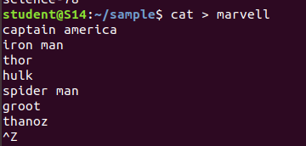

1. Cat > filename :- Create a new file and add content to that file.

$cat > marvel2

**Output Screenshot**

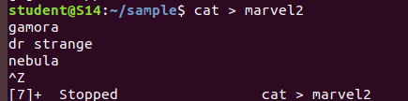

1. Paste:- join files horizontally by outputting lines consisting of lines from each file

Specified, separated by tab as delimiter, to the standard output.

$paste marvel1 marvel2

**Output Screenshot**

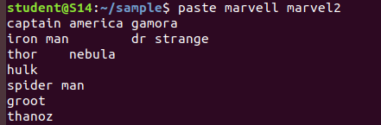

1. $paste marvel1 marvel2 > marvel3

$cat marvel3

**Output Screenshot**

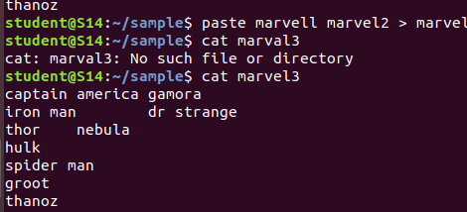

1. $paste –d ‘-‘ marvel1 marvel2

**Output Screenshot**

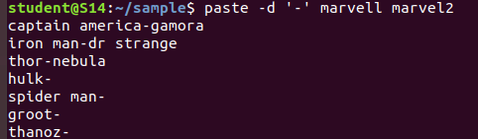

1. $paste –d ‘%|’ marvel1 marvel2 marvel3

**Output Screenshot**

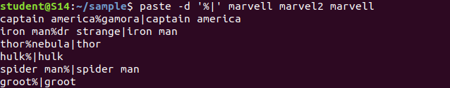

1. $paste –s marvel1 marvel2

**Output Screenshot**



1. Cat > demo2

**Output Screenshot**

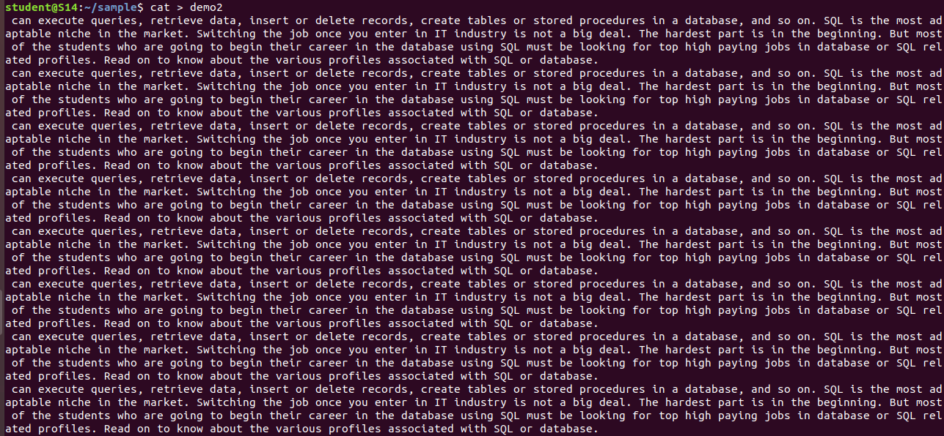

1. More demo2

**Output Screenshot**

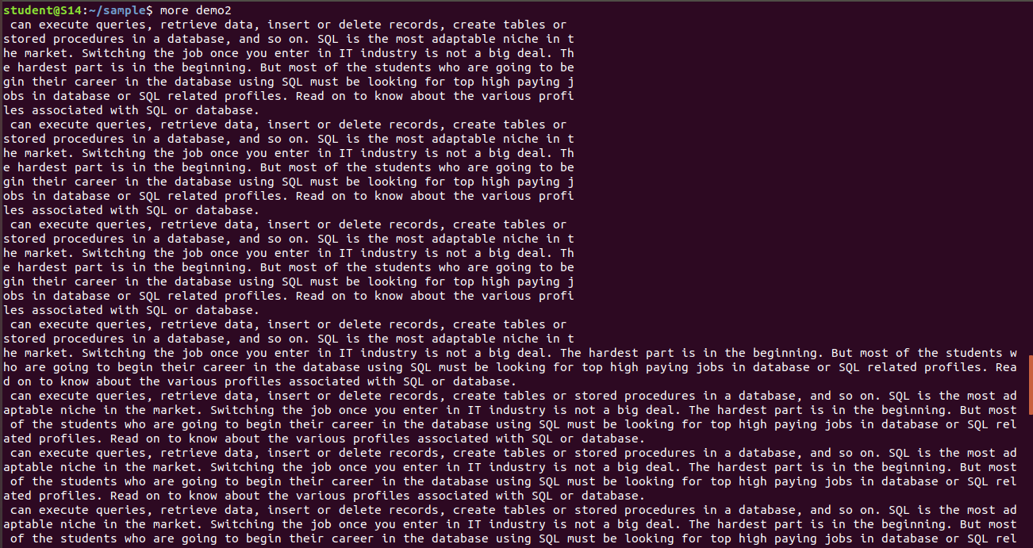

1. More -3 demo2

**Output Screenshot**

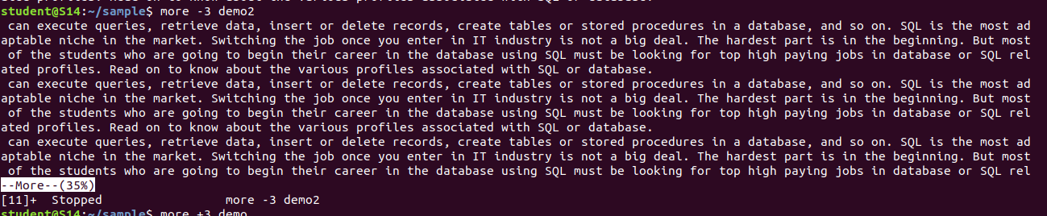

1. More +3 demo2

**Output Screenshot**

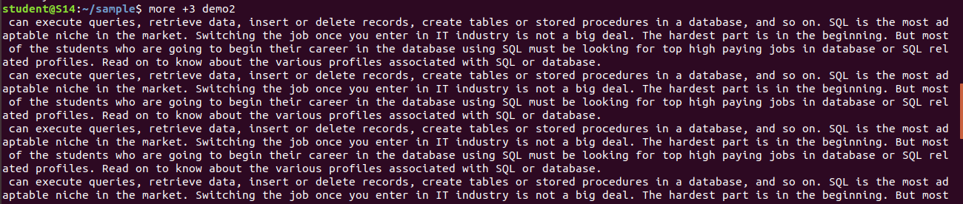

1. More –s demo2

**Output Screenshot**

